Tittle
COMP5048 Assignment 2

I Introduction
The dataset used in this report comes from the UCI Machine Learning Repository and records hourly air-quality measurements in an Italian city [1], [2]. It contains sensor responses, reference pollutant concentrations and weather measurements. Each record represents one hour, allowing observations with similar pollution profiles to be compared across days and seasons. This report analyses 9,357 observations from 10 March 2004 to 4 April 2005.
The analysis addresses three connected questions, the first one is which hours share similar sensor and environmental profiles, and how these groups and their defining attributes change over time, and how projected profiles change under environmental what-if scenarios at critical moments.

II Data
After discussing the data provided by the dataset, we ultimately selected the following data as the reference for our research and analysis, the selected measurements are PT08.S1(CO), C6H6(GT), PT08.S3(NOx), PT08.S4(NO2), PT08.S5(O3), temperature (T), relative humidity (RH) and absolute humidity (AH). The PT08 fields are labelled S1, S3, S4 and S5 in the charts and record sensor responses. C6H6(GT) is the reference benzene concentration in µg/m³ [2]. Benzene provides a concentration reference for the sensor profiles, while T, RH and AH describe weather conditions and provide inputs for the environmental scenarios.
The main reason we selected this dataset was its data coverage. After conducting preliminary data integration we found that the eight measurement fields have missing values in the same 366 hours, leaving 8,991 complete profiles (96.09%). The concentration-focused alternative has 25.82% incomplete rows. CO(GT), NOx(GT) and NO2(GT) each have about 17.5–18.0% missing values, and NMHC(GT) has 90.23%. PT08.S2(NMHC) was excluded because it closely follows benzene (r = 0.982), reducing redundancy while retaining the environmental measurements needed across tasks.
For data preparation, the source CSV was read using semicolon separators and comma decimals. We removed 114 entirely empty rows and two empty placeholder columns, then converted −200 measurements to missing values without imputation. All 9,357 hourly records were retained, with complete profiles used where a view requires all eight measurements. The prepared dataset allows us to compare sensor responses under different environmental conditions.

III Discovery of Grouping (Task 1)
The cleaned data were displayed using a scatterplot matrix for a preliminary visual analysis of the eight selected measurements (Figure 1). Each point represents one hour. Columns represent the horizontal axis attributes, while rows represent the vertical axis attributes, allowing relationships between attributes to be compared within the same dataset. The order of S1, C6H6, S3, S4, S5, T, RH and AH places the relationships between the sensors and benzene before the meteorological conditions. Retaining labels with the original units keeps the meaning of each measurement indicator clear. Smaller semi-transparent points reduce overlap, while seasonal colours reveal differences in temporal composition.
The matrix was chosen to compare several possible grouping attributes before selecting a region. The same hourly records appear in every panel, so a pattern in C6H6–S4 can be checked against C6H6–S1 and the environmental panels. A single scatterplot would hide these alternative relationships. Season is a categorical colour encoding: it identifies when a profile occurs, while position represents the measured values. The colours therefore help distinguish seasonal composition from differences in sensor response.
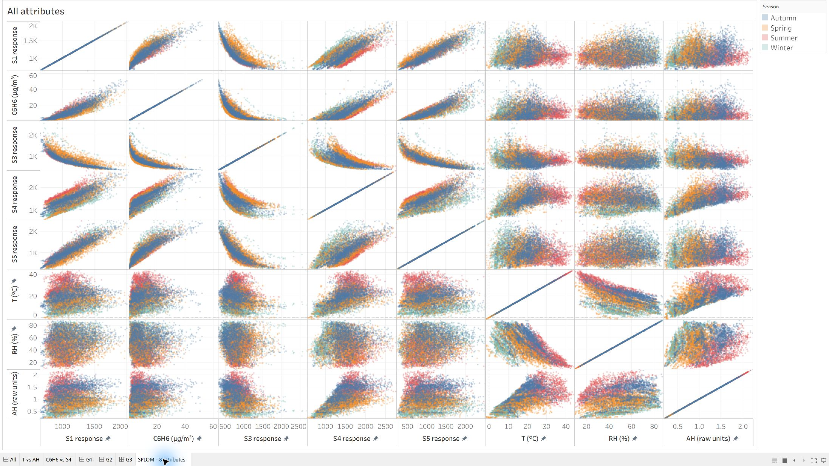
The matrix shows rising bands between C6H6 and S1, S4 and S5, together with a descending relationship between C6H6 and S3. Within C6H6 = 5–15 µg/m³, the C6H6–S4 panel contains both a lower-response region and an upper-response region. The C6H6–S1 panel also contains a tail with high benzene and high S1.
The follow-up inspection kept the same records selected while switching between scatterplots and parallel coordinates. This distinguished a region that looked compact in two dimensions from hours that also shared a multivariate profile. Attribute ranges were recorded after these visual comparisons, so they serve as reproducible descriptions of the observed regions. The grouping procedure used manual selection, with no clustering algorithm. The environmental views helped characterise the selected sensor patterns and refine the G3 core.
These visual observations informed three comparison groups: G1, G2 and G3. G1 and G2 retain contrasting S4 regions within a shared benzene interval. G3 retains the high-benzene, high-S1 region, with narrower T and AH ranges defining a compact core.
Each group retains all eight measurements, together with DateTime and RecordID. Independent group dashboards allow the selected records to be examined without the dense background of all hours. Each line represents one hour; the sensor and benzene axes precede T, RH and AH. Fixed global ranges support comparison across groups, and the labels retain original units. Thin translucent lines reveal repeated profiles, while consistent seasonal colours show when those profiles occur.
The overview was subsequently refined to place three compact group profiles above the all-hours parallel-coordinates view. G1 and G2 show C6H6, S4, T and AH; G3 shows C6H6, S1, T and AH. These subsets foreground the defining attributes and environmental context, while the lower view retains all eight measurements. Group colours distinguish the compact profiles; seasonal colours remain in the full and independent views. Selecting a group highlights its members against the full background, preserving the reference population.
Each parallel axis uses the minimum and maximum of that attribute across the 8,991 complete hourly profiles. Values are rescaled only for display, with original values retained in labels and tooltips. Keeping these ranges fixed prevents a narrow group from appearing to span the full range through automatic rescaling. Within the independent dashboards, selection links scatterplots and parallel coordinates by RecordID, while DateTime tooltips identify individual hours. The detailed views therefore inspect the same selected records from complementary perspectives.

G1 Low S4 responses and cooler conditions
G1 selects C6H6 between 5 and 15 µg/m³ and S4 response at or below 1100, retaining 468 hours. This captures the lower S4 region observed in the overall matrix.
The purpose of G1 is to isolate a clear lower-response part of the band while retaining enough benzene variation to compare with G2. Its S4 boundary captures a recognisable region of the overall point cloud, rather than a gap separating an isolated cluster. T, RH and AH were left unrestricted, allowing their patterns to emerge during inspection of the selected hours.
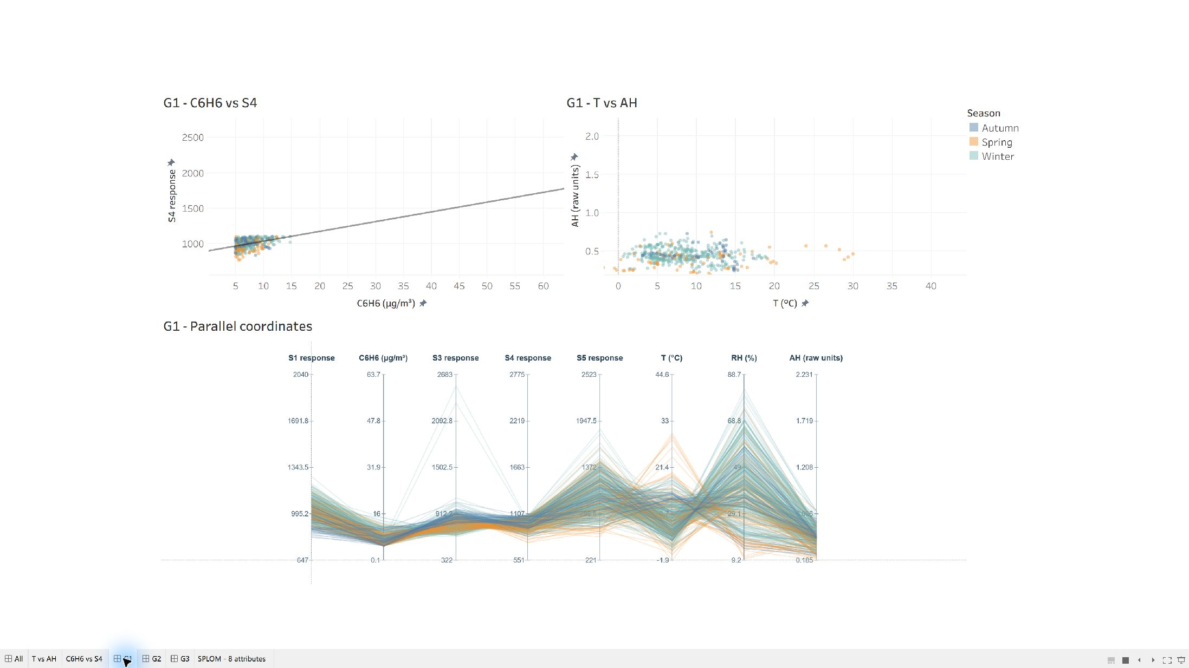
In Figure 2, lines form a narrow band on the S4 axis and also gather towards the lower ranges of S1 and AH. Most temperature values are relatively low, whereas RH and S5 spread more widely. The shared S4 profile therefore occurs mainly under cooler, low-AH conditions, with variation in the other attributes. Record summaries support the seasonal pattern: 345 hours are in winter and median T is 8.1 °C. The independent C6H6–S4 scatterplot focuses on the defining region, and T–AH shows its environmental spread.
The views show how the selected region relates to the other attributes: the compact C6H6–S4 region corresponds to a repeated low-S4 line bundle, while the T–AH view reveals the cooler, low-AH context. G1 occurs on 78 dates, so it represents a recurring profile rather than one continuous episode. The wider RH and S5 spread shows that similarity is stronger on some attributes than others. The independent dashboard makes this variation easier to see without the full dataset obscuring the group.

G2 Higher S4 responses and warmer conditions
G2 selects the same C6H6 interval of 5–15 µg/m³ but S4 response at or above 1700, retaining 645 hours. The upper S4 region provides a contrast with G1 without changing the benzene interval.
G2 provides the upper-response counterpart to G1. Retaining the same benzene interval makes the S4 contrast easier to inspect than comparing unrelated parts of the concentration range. Temperature and humidity were again unrestricted. Consequently, the warmer profiles and seasonal composition are additional observations associated with the selected S4 region, rather than conditions imposed to create a summer group.
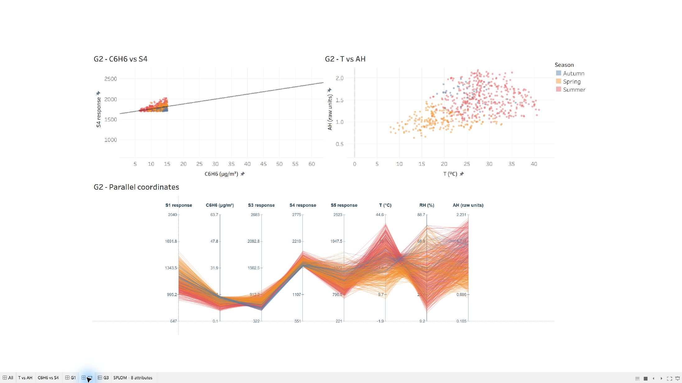
In Figure 3, the S4 line bundle sits visibly higher than in G1, while many lines extend towards higher T and AH. Summer-coloured lines occupy much of the upper temperature range. The wider environmental spread shows that the common S4 pattern occurs across varied weather conditions. Record summaries give 410 summer hours and median T of 25.7 °C. These environmental features describe the selected group; they did not define its boundaries. The independent dashboard retains C6H6–S4 and T–AH scatterplots. Using the same axis order and global ranges as G1 in the parallel coordinates makes the higher S4 band and environmental contrast directly comparable.
G2 appears on 155 dates, and its T–AH values occupy a broader region than G1. This supports a shared sensor-response region across several environmental settings, rather than a uniform weather profile. The C6H6–S4 scatterplot makes the upper band explicit, whereas the T–AH panel shows variation within that band. The eight-axis view then places both observations alongside S1, S3, S5 and RH.

G3 High benzene and a repeated sensor profile
G3 selects C6H6 ≥ 25 µg/m³ and S1 response ≥ 1400, then retains 18 ≤ T ≤ 26 °C and 1.4 ≤ AH ≤ 1.8. These conditions identify 92 hours in a compact part of the high-benzene, high-S1 tail.
The initial high-benzene, high-S1 selection contained 371 hours and a broader environmental spread. Inspection of its T–AH view identified a more compact local region, which was retained as the 92-hour G3 core. The environmental bounds therefore refine an already visible sensor–benzene pattern. In contrast with G1 and G2, environmental attributes form part of this group's definition, so the strongest additional evidence comes from sensors that were not used to select it.
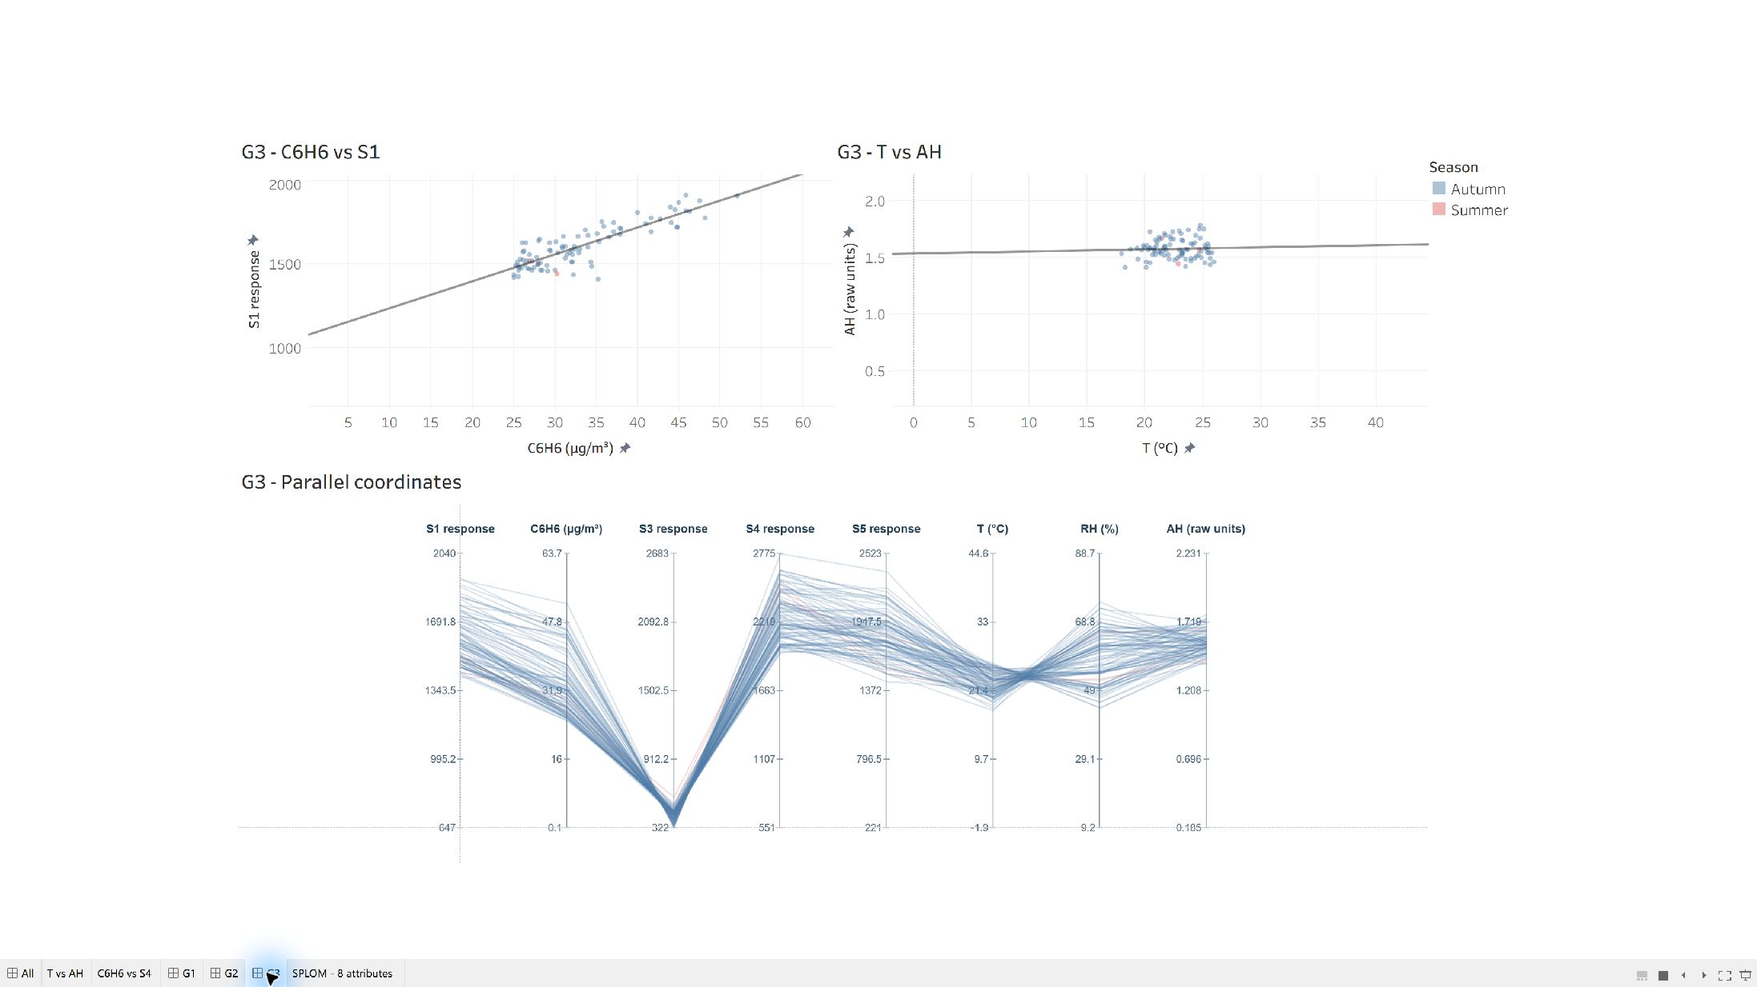
Figure 4 shows a repeated profile: lines converge at low S3, rise to high S4 and remain relatively high at S5. These three sensors were not selection criteria, so their shared shape provides additional visual evidence of similar profiles. Record summaries show S3 values of 325–588. The group spans 33 dates and includes 89 autumn hours, indicating that similar profiles recur on different days.
The independent dashboard uses C6H6–S1 to examine the defining sensor relationship and T–AH to show the selected environmental range. Displaying all eight parallel axes keeps the additional S3, S4 and S5 evidence visible alongside the selection attributes.
Across the selected hours, S4 ranges from 1970 to 2775 and S5 from 1449 to 2372. Alongside the low S3 range, these measurements explain the repeated low-to-high shape visible in Figure 4. The C6H6–S1 pairing foregrounds the high-benzene, high-S1 tail that motivated G3. The parallel-coordinates view retains the other sensors, allowing the defining region and the additional evidence to be read together. These ranges describe the selected profile after inspection; the shared line shape provides the visual evidence.
Together, G1 and G2 describe contrasting sensor responses within one benzene interval, while G3 captures a higher-benzene profile with a repeated pattern across several sensors.

C Limitations
Visual grouping depends on which regions are inspected and where manual boundaries are drawn. The matrix contains largely continuous bands, so these selections describe contrasting profiles rather than three completely separated natural clusters. Together they retain 1,205 hours: 13.4% of the 8,991 complete profiles, or 12.9% of all 9,357 records. Selecting clearer regions improves interpretability but leaves most hours outside the groups.
Dense points can hide sparse patterns in the matrix, and each panel shows only two attributes at a time. Parallel coordinates display all eight attributes, but overlapping lines, axis order and the ranges shown affect which patterns are easiest to see. Fixed global ranges support group comparisons while compressing narrow within-group differences. Transparency, brushing and independent group views reduce clutter, but screenshots cannot reproduce the interactive selection process.
Seasonal colours show composition but do not establish the sequence or duration of events; those questions require the linked time records. Linear trend lines in the independent scatterplots assist reading the direction of an association, but do not define the groups. Their extension into regions without points is not evidence of observed behaviour. These design choices support profile comparison, while the timing and persistence of each profile require the temporal analysis in Task 2.
The groups also differ in dates and benzene distributions. In particular, G1 begins on 8 November 2004, whereas G2 ends on 1 November 2004; their observed date windows do not overlap. G1 and G2 have benzene medians of 6.8 and 12.5 µg/m³, so their weather contrast is an association rather than a controlled comparison. G3’s compact T–AH pattern partly follows its selection conditions. Sensor responses are not direct pollutant concentrations, and drift and cross-sensitivity limit their interpretation [1], [2].

References
[1] S. De Vito, E. Massera, M. Piga, L. Martinotto, and G. Di Francia, “On field calibration of an electronic nose for benzene estimation in an urban pollution monitoring scenario,” Sensors and Actuators B: Chemical, vol. 129, no. 2, pp. 750–757, 2008, doi: 10.1016/j.snb.2007.09.060.
[2] S. De Vito, “Air Quality,” UCI Machine Learning Repository, 2008. [Online]. Available: https://doi.org/10.24432/C59K5F.

